Living Hope, a study of 2 Peter

Wk #30: Learning To Live Our New Potential

2 Peter 1:1-11 ESV

*Simeon Peter, a servantand apostle of Jesus Christ,*

*To those who have obtained a faith of equal standing with ours by the righteousness of our God and Savior Jesus Christ:*

***2****May grace and peace be multiplied to you in the knowledge of God and of Jesus our Lord.*

***3****His divine power has granted to us all things that pertain to life and godliness, through the knowledge of him who called us tohis own glory and excellence,* ***4****by which he has granted to us his precious and very great promises, so that through them you may become partakers of the divine nature, having escaped from the corruption that is in the world because of sinful desire.****5****For this very reason, make every effort to supplement your faith with virtue, and virtue with knowledge,****6****and knowledge with self-control, and self-control with steadfastness, and steadfastness with godliness,****7****and godliness with brotherly affection, and brotherly affection with love.****8****For if these qualitiesare yours and are increasing, they keep you from being ineffective or unfruitful in the knowledge of our Lord Jesus Christ.****9****For whoever lacks these qualities is so nearsighted that he is blind, having forgotten that he was cleansed from his former sins.****10****Therefore, brothers, be all the more diligent to confirm your calling and election, for if you practice these qualities you will never fall.****11****For in this way there will be richly provided for you an entrance into the eternal kingdom of our Lord and Savior Jesus Christ.*

Our last study time together before our three outdoor services we discussed our new potential that we have in Jesus Christ. We used the analogy of an incredible household food pantry. The goal was to help us have a visual image of the incredible provision and power that Christ has made available to us.

Scholars say that when Peter shares these words with the exiles who are living in modern day Turkey about 30 years after his time walking life with Jesus of Nazareth.

Let's remember that then New Testament is a record of events that primarily played out in what we now call the Middle East, Southeastern Europe, and Asia Minor.

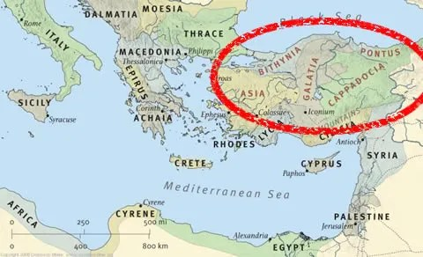

Peter appears to be writing the second epistle to the same exiles that he addresses in his first letter.

Christians who have been exiled or scattered to regions that were not their original home of origin. They are basically living in foreign regions.

Peter is writing to encourage and challenge brothers and sisters who were living in perilous times of persecution.

These people were hated and despised by other "religious" people simply because they followed the teachings of a man who did not respond in hate but in love.

Sounds a lot like our current world.

Let me simply remind you of some things as we jump back into our study of 2 Peter together.

***"as His divine power has given to us all things that pertain to life and godliness"***

***"by which have been given to us exceedingly great and precious promises,"***

***"partakers of the divine nature"***

There is so much mind boggling truth in these verses. I know it can be hard to believe but I am proclaiming that we must believe what Peter is relaying to us from his own personal experience with the Lord through the power of the Holy Spirit.

**Faith is not the absence of doubt or fear but rather the reality of acting on what God says about Himself as well as what He wants for us based on what He has already done for us.**

Pause..............wait..................reread slowly

***"having escaped the corruption that is in the world through lust. (because of sinful desire)"***

Corruption meaning moral decay

Desire, craving, or longing; especially a desire for what is forbidden

We can escape or flee the impact of this world on our lives.

Not by removing ourselves or physically running away from people and society but by being radically changed in our hearts and minds by the power of God.

Peter has been on both sides of the struggle.

You can read about his human struggles to understand the way of Christ.

**Now Peter is explaining the powerful depths of this potential that he has learned to live.**

Each and every one of us must make a personal decision to believe that this new spiritual potential is possible.

This is often accomplished by watching, listening, and learning from other people........

Examples the last three services from Evan & Karen, Joey & Brittnee, and Josh & Meghan proclaims potential to our church family as well as guests.

This process becomes incredibly special when someone says..............***"hey, I believe in you!"***

Let me share three observations regarding what happens when we begin to press toward our new potential:

* Faith creates a positive environment of higher expectations (potential)
* Faith applied in family should create input and feedback for growth and development (potential applied)
* Proclaiming potential and faith in someone means investment of time and resources (potential in action)

**Believing in someone's potential in Christ is a posture of the heart!**

Let's be a church that is learning how to encourage people for where they are and their potential instead of their past and their mistakes/failures.

**It does not take the greatest faith on the planet but it does take enough faith to take action.**

**Faith is not the absence of doubt or fear but rather the reality of acting on what God says about Himself as well as what He wants for us based on what He has already done for us.**

Let's learn to live in our new potential and take people with us as we learn!!!!