Living Hope, a study of 2 Peter
Wk #37: Jesus Potential Embraced

Last week's lesson: Who & What Still Matters

2 Peter 2:1-3 NKJV
But there were also false prophets among the people, even as there will be false teachers among you, who will secretly bring in destructive heresies, even denying the Lord who bought them, and bring on themselves swift destruction. ² And many will follow their destructive ways, because of whom the way of truth will be blasphemed. ³ By covetousness they will exploit you with deceptive words; for a long time their judgment has not been idle, and their destruction does not (will not) slumber.

This week, we are going to take an interlude. In other words, we are taking an intervening episode between some powerful verses. Before we jump into verses 4-12.

We must know the truth of the Word of God to not be deceived by false prophets and false teachers within the church.
We must know the truth of the teachings of the Bible to not be deceived by the false presenters and influencers in our world.

We must also know the truth of the Scriptures to not be deceived by the most personal of the false proclaimers, influencers, or teachers in our lives...........SELF or OURSELVES!!

Peter has been proclaiming some incredibly powerful, life altering truths to literally transform our human existence.

What is keeping most of us from pressing in to these incredible truths?

Why are we not living with God's divine character and nature on display in our lives?

The simple answer is that most of us proclaim falsehood over ourselves!

How?

Fears
Fear of failure
Fear of the unknown.........change for many is scarier than the pattern of sin and failure
Sort of like controlled misery of Self
Terrified of releasing control to God

Past sins and failures that we allow to define us

Lies we preach to ourselves............every single day and all day long

To live as Peter has described is to live a life of incredible freedom, joy, and power!

In one of his early books titled The Winning Attitude when John Maxwell was still pastoring Skyline Wesleyan Church he says:
"Look around you. Analyze the conversations of people who lead unhappy, unfulfilled lives. You will find they are crying out against a society which they feel is out to get them and to give them a lifetime of trouble, misery, and bad luck. Sometimes the prison of discontent has been built by their own hands.
The world doesn't care whether we free ourselves from this prison or not. It marches on. Adopting a good, healthy attitude toward life does not affect society nearly so much as it affects us. The change cannot come from others. It must come from us.
The apostle Paul had a terrible background to overcome. He told Timothy that he was the "chief of sinners." But after his conversion he was infused with desire to know Christ in a greater way. How did he fulfill this desire? Not by waiting for someone else to assist him. Neither did he look backward and whine about his terrible past. Paul diligently "pressed on to lay hold of Jesus." His singleness of purpose caused him to state, "But one thing I do: forgetting what lies behind and reaching forward to what lies ahead, I press on toward the goal for the prize of the upward call of God in Christ Jesus". (Philippians 3:13-14)
We are individually responsible for our view of life. The Bible says, "Whatever a man sows, this he will also reap." (Galatians 6:7) Our attitude and action toward life help determine what happens to us.
It would be impossible to estimate the number of jobs which have been lost, the number of promotions missed, the number of sales not made and the number of marriages ruined by poor attitudes. But almost daily we witness jobs that are held but hated and marriages that are tolerated but unhappy, all because people are waiting for others, or the world, to change instead of realizing that they are responsible for their behavior. God is sufficient to give them the desire to change, but the choice to act upon that desire is theirs."

Self lies (self deception), self falsehood (another form of self deception), and self loathing (self hatred) are at the root of many of our debilitating struggles.

To live as Peter has described is to live a life of incredible freedom, joy, and power!

This can be experienced by anyone who will believe/trust in Jesus as the Son of God, take personal responsibility, and learn/follow the ways of Jesus.

I repeat anyone............anyone can experience a life altering trajectory through Christ!!

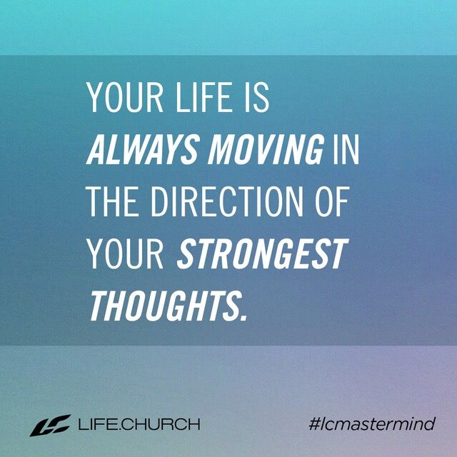

Peter was testifying of what he had experienced in his life.
He knew the difference between his own power and the power of Almighty God in his life.

I am testifying of what I have experienced in my life.

I know the difference between my own efforts/power and learning to experience God's provision and power.

I am still seeking, learning, and growing. I want to walk in my Jesus potential.

We don't teach just to go through the Bible but rather to challenge, encourage, and cast a vision for the incredible, life altering relationship that we can experience through Jesus our Savior and Lord.

Our potential is next level, off the charts because of the character and the power of God available to us.

Potential.............just consider the concept
Merriam-Webster dictionary (current) Noun: something that can develop or become actual

Potential versus Mediocrity

Philippians 2:5 NIV In your relationships with one another, have the same mindset as Christ Jesus:

The gospel generates life altering power, not just once for salvation but for each and every day in the process of sanctifying work of salvation. It is a growing relationship.

Real influence is about relationships

The power of God creates potential as well as influence.

We discussed being careful about the people that influence your life.

The reason this is such a difficult battle for most of us is the reality that God's plan involves using each and every one of us to influence other people regarding Jesus power to save and rescue.

Men, your influence matters. You affect those around you. If you are married or if you have children, you influence toward godliness or ungodliness.

Ladies, your influence matters.

Children and young people, your influence matters.

Colossians 3:17 NLT And whatever you do or say, do it as a representative of the Lord Jesus, giving thanks through him to God the Father.

Real influence for the kingdom of God is all about relationships.

Embrace your Jesus potential.
Learn it.
Live it.
Love it.

Make it your own

